**cid:image001.jpg@01CB8642.CB58A960**NEWS FROM

For Immediate Release:

April 21st, 2016

**FIDELITY BANK SPONSORS NEW LAPTOPS TO ICAN READING PROGRAM**

*Nassau, Bahamas*: Fidelity Bank (Bahamas) Limited donated laptops to ICAN, a local literacy program for assist at-risk youth. Founded in 2006 by philanthropist, Tehranique Darrell, ICAN is a registered non-profit organization that provides a solution to the negative repercussions of illiteracy and neglect, including academic failure, low self-esteem, substance abuse, teenage pregnancy and criminal activity. ICAN offers a solution through its provision of a safe, positive and supportive environment for at-risk children at its location on Recovery Way (formerly St. Alban’s Drive). It also provides creative childhood learning programs – iempower, iread, igrow, icreate, idiscover and iprotect.

Through its programs, ICAN provides a unique and innovative way to reach at-risk children outside of the traditional forms of learning, i.e. reading, writing and arithmetic. Rather, these concepts are taught through art, crafts, and other hands-on experiences like farming, horseback riding and outdoor adventures. ICAN implements the AutoSkill program to assist with reading and math and to provide accurate progress tracking and statistics.

“We are so thankful to Fidelity for its annual sponsorships as well as its donation of the laptops,” says Mrs. Darrell. “In the past, our students would have to share laptops during tutoring sessions which had an impact on individual progress. With the additional machines, we expect that we can see even better progress reports.”

Chief of Compliance and Fidelity Groups Donations Committee Chair, Tangela Albury commended ICAN for its commitment to youth development. “We enthusiastically supports ICAN’s vision to increase literacy in the Bahamian community as it reflects Fidelity’s guiding principles. We are all too aware of the impact of education or the lack thereof in the community. The underlying issue, in a number of cases, is the inability of the public school system to cater to the individual needs of the entire student population. The burden is too great. Programs like ICAN help to bridge the educational gap, making it possible for more students to succeed.”

Fidelity Bank sponsors five students annually to participate in the ICAN program. The sponsorship assists in providing food and drink, purchasing materials and providing stipends to volunteers.

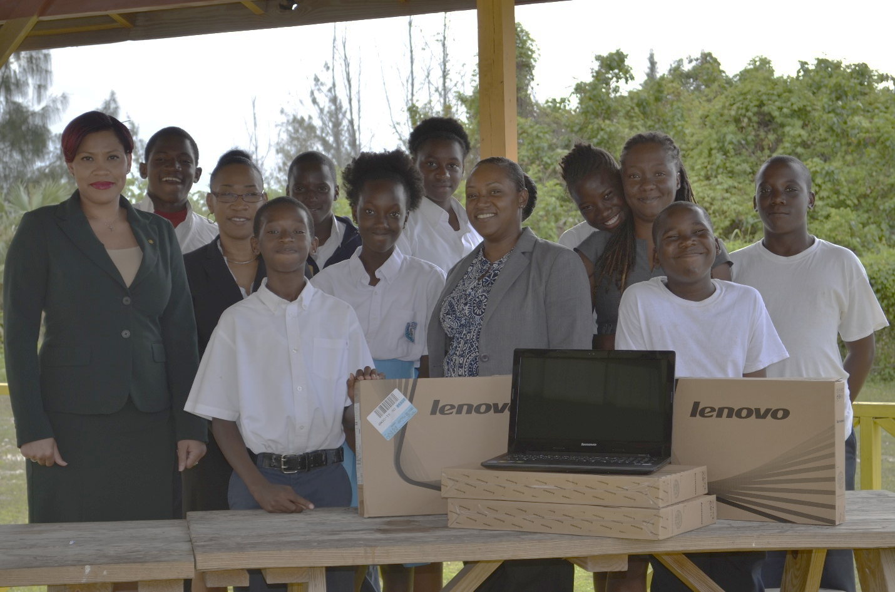

From left to right: Karen Major, Investment Manager, Royal Fidelity Merchant Bank & Trust Limited; (middle left) Tangela Albury, Chief of Compliance, Donations Committee Chair, Fidelity Group of Companies, (front right) Cherilyn Bethel, Marketing/PR Coordinator, Fidelity Group of Companies, (middle right) Tehranique Darrell, founder, ICAN.

###

**About Fidelity**

Fidelity Bank (Bahamas) Limited is a 75% held subsidiary of Fidelity Bank & Trust International Limited (FBT) with the balance owned by the Bahamian public. FBT is a bank holding company incorporated in The Bahamas with licensed retail banking subsidiaries in The Bahamas and the Cayman Islands. FBT operates primarily in the personal banking segment and has consolidated assets of over $600 million. FBT also has a joint venture with Royal Bank of Canada which provides investment banking, corporate finance, and wealth management services through a 50/50 ownership of Royal Fidelity Merchant Bank &Trust Limited, which has operations in The Bahamas and Barbados.

**For more information contact:**

**Antonio Saunders**

**T.356.7764 Ext. 3129**

**E.** [**marketing@fidelitybahamas.com**](mailto:marketing@fidelitybahamas.com)