**cid:image001.jpg@01CB8642.CB58A960**NEWS FROM

For Immediate Release:

May 12, 2016

**FIDELITY BANK SUPPORTS AUTISM AWARENESS MONTH**

*Nassau, Bahamas*: Fidelity Bank (Bahamas) Limited along with the community helped to raise awareness for Autism Awareness Month through a Penny Drive during the month of April.

R.E.A.C.H. (Resources and Education for AUTISM and Related Challenges) was founded in 1998 as a voluntary support and advocacy group for persons and their families who are challenged by autism or related disorders. Autism is a lifelong, complex, neurobiological disorder, which is characterised by varying degrees of communication, socialisation and behaviour impairments. Autism affects one in every 68 children, according to the Centre for Disease Control and Prevention. And according to R.E.A.C.H., it is the fastest-growing serious developmental disability in the Bahamas. It occurs in all racial, ethnic and socioeconomic groups, but is almost five times more common among boys than among girls.

Among the challenges faced by the organization is the lack of services afforded to persons with autism, including early diagnosis, speech & occupational therapy, finding appropriate education, vocational training, job opportunities, respite care, and sheltered living facilities. R.E.A.C.H. has made great strides in addressing this issue through public awareness, advocacy programs and fundraising activities.

Fidelity Bank facilitated the penny drive to benefit REACH, where persons were able to donate to assist the organization in its efforts. Fidelity then matched the donations received. Ms. Tangela Albury, Fidelity Bank’s Chief Compliance & Control Officer and Donations Committee Chair presented the donation.

“We are so glad that corporate citizens like Fidelity Bank are partnering with us to assist children and adults with Autism and related disabilities,” says Mr. Dwayne Gibson, Chairman of the Board, R.E.A.C.H. “With the escalating number of children being diagnosed across the country, more has to be done to create the best scenario for them.”

For more information about R.E.A.C.H. please visit the Dewgard Plaza, Bradley Street, Palmdale or call: 328-4123

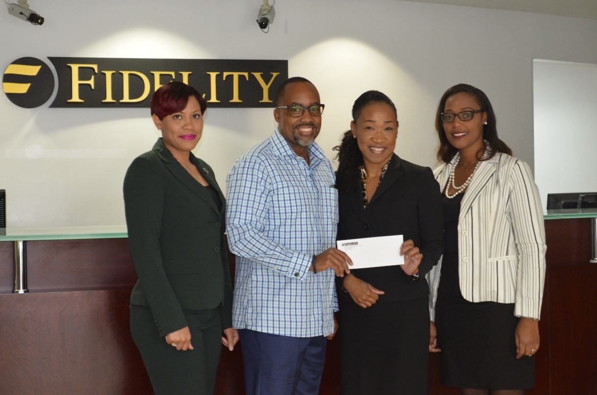

From left to right: Karen Major, Investment Manager & Donations Committee Member, Fidelity Group; Dwayne Gibson, Chairman of the Board, R.E.A.C.H.; Tangela N. Albury, Chief Compliance & Control Officer & Donations Committee Chair, Fidelity Group; Odia Gaskin, Financial Centre Manager &, Donations Committee Member, Fidelity Group.

###

**About Fidelity**

Fidelity Bank (Bahamas) Limited is a 75% held subsidiary of Fidelity Bank & Trust International Limited (FBT) with the balance owned by the Bahamian public. FBT is a bank holding company incorporated in The Bahamas with licensed retail banking subsidiaries in The Bahamas and the Cayman Islands. FBT operates primarily in the personal banking segment and has consolidated assets of over $600 million. FBT also has a joint venture with Royal Bank of Canada which provides investment banking, corporate finance, and wealth management services through a 50/50 ownership of Royal Fidelity Merchant Bank &Trust Limited, which has operations in The Bahamas and Barbados.

**For more information contact:**

**Antonio Saunders**

**T.356.7764 Ext. 3129**

**E.** [**marketing@fidelitybahamas.com**](mailto:marketing@fidelitybahamas.com)