**cid:image001.jpg@01CB8642.CB58A960**NEWS FROM

For Immediate Release:

July 12, 2016

**FIDELITY BANK SPONSORS THE BAHAMAS NATIONAL CHILDREN’S CHOIR**

*Nassau, Bahamas*: Fidelity Bank (Bahamas) Limited helped to send members of the Bahamas National Children’s Choir (BNCC) to Washington DC to perform this summer.

BNCC was formed in the summer of 1990 when sisters, Mrs. Patricia Bazard and Mrs. Audrey Wright, gathered twenty-five (25) students from government and private schools in the Bain Town area as a means to give back to that community. The purpose was to enable the children to identify with their culture, cultivate their many talents and provide opportunities for their individual development. The group became a National choir during the Quincentennial Celebrations in 1992, commemorating the first landfall of Christopher Columbus.

The members of the BNCC range in ages from five to fifteen years, representing various economic levels of society. The choir has a wide repertoire of music ranging from Bach to Blind Blake and performs in at least six languages. The choir performs for all Government and National Events, Bahamian Civic Organizations, business establishments, international Conferences and churches throughout New Providence and the Family Islands.

BNCC has also represented the Bahamas internationally performing in the United States and Europe. In 2001, the choir participated in First Annual World Youth Music Festival, where they were able to share their art form, particularly Bahamian music, with 83 choirs from Europe and Asia. During that time BNCC was privileged to host a full concert in world renowned venues such as the Grand Hall in Moscow and the Accapella Hall in St. Petersburg. The choir has also appeared on national and international networks like The Russian T.V., Network, B.E.T and Word Network, A.B.C. and N.B.C.

Chief of Compliance and Donations Committee Chair at Fidelity Bank, Ms. Tangela N. Albury commended the choir’s Director, Mrs. Bazard, for her commitment to youth development. “Not only does The Bahamas National Children’s Choir give these children the opportunity to develop their musical talents, but it also affords them the unique gift of travelling the world and experiencing other cultures. The positive effects of this exposure is tremendous, from building self-esteem, courage and resiliency to inspiring them about their future. Fidelity is pleased to be a part of that experience.”

Fidelity’s sponsorship allows students, Joshua and Waynette Munnings, to travel to Washington. The group is expected to tour the state during July 14th – 19th.

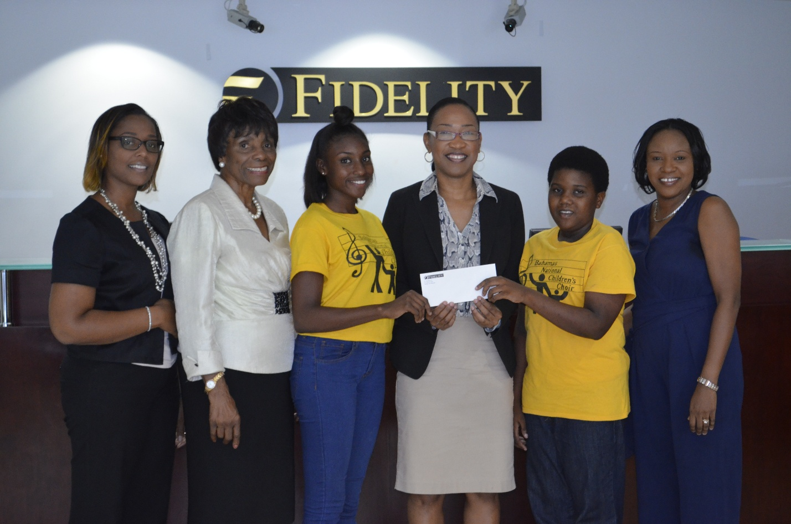

From left to right: Odia Gaskin, Financial Centre Manager, Fidelity Bank; Patricia Bazard, Director, Bahamas National Children’s Choir; Waynette Munnings, Member, Bahamas National Children’s Choir; Tangela Albury, Chief of Compliance, Donations Committee Chair, Fidelity Group of Companies; Joshua Munnings, Member, Bahamas National Children’s Choir; Parent of Waynette and Joshua.

###

**About Fidelity**

Fidelity Bank (Bahamas) Limited is a 75% held subsidiary of Fidelity Bank & Trust International Limited (FBT) with the balance owned by the Bahamian public. FBT is a bank holding company incorporated in The Bahamas with licensed retail banking subsidiaries in The Bahamas and the Cayman Islands. FBT operates primarily in the personal banking segment and has consolidated assets of over $600 million. FBT also has a joint venture with Royal Bank of Canada which provides investment banking, corporate finance, and wealth management services through a 50/50 ownership of Royal Fidelity Merchant Bank &Trust Limited, which has operations in The Bahamas and Barbados.

**For more information contact:**

**Antonio Saunders**

**T.356.7764 Ext. 3129**

**E.** [**marketing@fidelitybahamas.com**](mailto:marketing@fidelitybahamas.com)